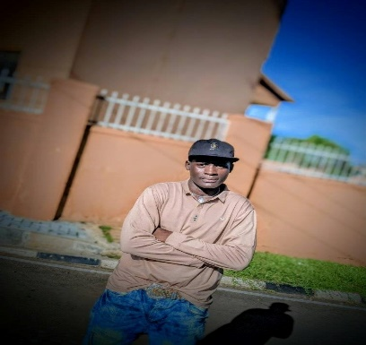
- Building personal web projects and exploring new technologies
- Solving coding challenges and puzzles
- Reading tech blogs and staying updated with industry trends
- Playing chess and strategy games
- Outdoor activities like hiking and cycling
- Volunteering in community tech workshops

HOBBIES
**Bachelor of Science in Computer Science**
University of Jordan, Amman, Jordan
September 2016 – June 2020

eEDUCATION

Front-End Developer with 5 years of hands-on experience specializing in HTML, CSS, JavaScript, React, and Git. Skilled in building responsive, user-friendly web applications and collaborating in fast-paced team environments. Adept at translating design concepts into high-quality code, optimizing performance, and continuously learning new technologies. Proficient in Python, adding versatility to solve a wide range of development challenges. Committed to delivering exceptional digital experiences and contributing to successful project outcomes.

Summary
Skills
- HTML
- CSS
- JavaScript
- GIT
- React
- Github

 +256 751065765

 alainbuhashe87

 Uganda , Kampala

Amani Jordass
Amani Jordan

